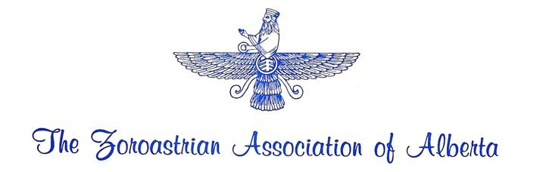APPLICATION FOR MEMBERSHIP
  - Membership in the Zoroastrian Association of Alberta does not automatically entitle the applicant to be considered a Zarathushti/Zoroastrian/Parsi or any connotation thereof.

  - Form is to be filled out by each ADULT member of the family.

FULL NAME (BLOCK letters please):

ADDRESS (BLOCK letters please):

ALBERTA POSTAL CODE

TELEPHONE: Residence Business/Cell

E-MAIL ADDRESS

FAMILY MEMBERS (including spouse, children & dependents):
NAME | PROFESSION | SEX | CHILDREN’S  BIRTH DATE

If additional space required, please attach an extra sheet

Please indicate “ADULT” if over 18 years of age. In case of children, birth dates are preferred as they help organize children’s’ activities, gifts/prizes, etc,

ANNUAL FEES:
Regular Membership of the Zoroastrian Association of Alberta (“ZAA”) is:
Can$ for FAMILY and Can$ for SINGLE ADULT.

Fees for SENIOR CITIZENS, 65 years old and over is at 50% of the prescribed rates.

Fees are non-refundable and are payable on an annual basis for ZAA’s fiscal year commencing from June 1st to May 31st.

I, the undersigned, hereby apply for membership of ZAA under the category of FAMILY/ SINGLE ADULT/SENIOR CITIZEN (delete which is not applicable) and declare/affirm that I am/ am NOT a Zarathushti/Zoroastrian/Parsi and 18 years of age or over, and that I am a legal resident of the Province of Alberta, and that I have read and understood the objectives and by-laws of the ZAA and agree to abide by them.

Date Signature

